Health & Safety policy
Liberty in the Wild Ltd

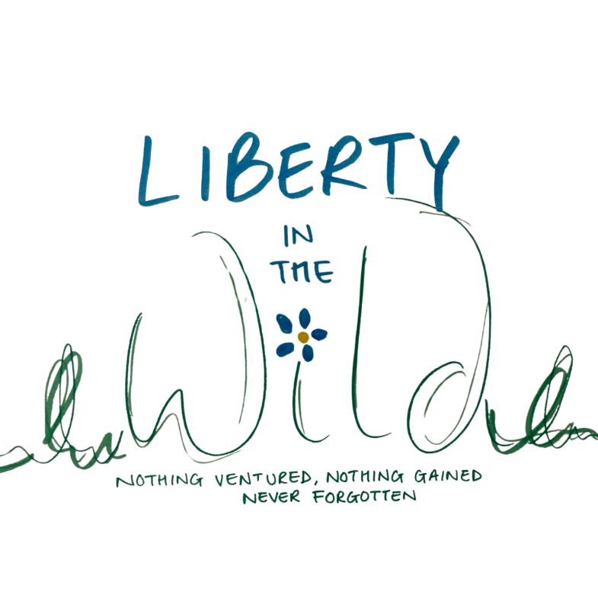

Approved by: | Kamilla Woodburn-Minott  Liz Crowford
Last reviewed on: | September 2024
Next review due by: | September 2025

This policy has been written with, and must be read with reference to DfES Guidance 0803/2001
'Health & Safety: Responsibilities and Powers', the Health & Safety at Work Act (1974), The
'COSHH: A brief guide to the Regulations' (2002) and 'An Introduction to Health & Safety' (in Small Businesses; HSE, 09/04)

As Liberty in the Wild Ltd is currently a tenant of the Umberslade Estate, the policy reflects that of the estate and is in compliance with it.

In the terms of The Health & Safety at Work Act (1974), the employers with regards to this policy are Liberty in the Wild Ltd and Umberslade Estate.

Policy Statement

Liberty in the Wild Ltd will:

- Provide a happy, secure, healthy and caring environment
- Establish and maintain safe working procedures amongst staff and pupils
- Maintain all areas under the control of the Directors and staff in a condition that is safe and without risk to health, and provide and maintain means of access to and exit from places of work that are safe and without risk
- Formulate effective procedures for use in case of fire and for evacuation of the centre premises
- Formulate procedures to be followed in the case of accidents and emergencies
- Make arrangements for ensuring safety and absence of risks to health in connection with the use, handling, storage and transport of articles and substances
- Provide sufficient information, instruction and supervision to enable all staff and Pupils to avoid hazards and contribute positively to their own health and safety and that of others, and ensure access to health and safety training, as appropriate
- Embed the teaching of safety in the curriculum
- Provide and maintain adequate welfare facilities

1. Health & Safety Statutory Duties

1.1 Directors and Advisors
1.1.1 Monitor the effectiveness of the safety policy and safe working practices, revise and amend, as necessary, on a regular basis and bring any changes to the full attention of employees, staff and Pupils
1.1.2 So far as is reasonably practical, ensure that all activities under their control are carried out in accordance with The Health & Safety at Work Act (1974)
1.1.3 So far as is reasonably practical, seek to exceed the minimum requirements within the resources available to keep all employees, staff and Pupils safe and healthy
1.1.4 Expect, in return, all employees and staff to fulfil their minimum legal duties of care to include co-operating with the Delegated Person in carrying out procedures, as required
1.1.5 Prepare the emergency evacuation procedure, put in place periodic practice evacuation drills and record the results of each drill
1.1.6 Undertake Enhanced DBS Checks & List 99 on all grades of staff appointed
1.1.7 Include the centre's Health & Safety Policy and procedures, Accident Reporting procedures and Safety Guidelines in writing in: (i) the Staff Handbook (ii) the Staff Induction Programme (for both teaching and non-teaching staff) and (iii) Staff Training Days
1.1.8 Ensure that staff make Health and Safety and centre safety procedures part of the delivered curriculum
1.1.9 Ensure adequate first-aid provision, procedures and training are in
1.1.10 Ensure that incidents, accidents and dangerous occurrences are investigated, reported and preventative measures
1.1.11 Ensure that regular safety inspections are undertaken (one per term), arrange for regular Risk Assessments to be completed, make and collate safety reports and make arrangements for implementation of recommendations
1.1.12 Arrange for the withdrawal, replacement or repair of any item of furniture, fitting or equipment identified as being unsafe
1.1.13 Report to the Facilities Manager any problems in the state of repair of the buildings and surrounds which is identified as being unsafe and make interim arrangements to limit the risks present
1.1.14 As far as is reasonably practical; monitor the activities of contractors, works people and other organisations present on site
1.1.15 Identify and nominate a member of staff to assist the Headteacher in the management of Health & Safety at the centre
1.1.16 Ensure that goods purchased comply with necessary safety standards

2. Health & Safety Arrangements
Health and Safety is an issue for everyone at Liberty in the Wild Ltd, all staff have an obligation and duty under health and safety law to promote the health, safety and welfare of our community

2.1 Person Delegated to Assist
2.1.1 Assist the Directors in the implementation, monitoring and development of the safety policy
2.1.2 Assist with advice on the application of safety matters at the centre
2.1.3 Assist with arrangements for the design and implementation of safe working practices at the centre
2.1.4 Investigate any assigned health and safety problems identified within the centre and take/recommend remedial action to the Directors.
2.1.5 Have the authority to order that a method of working/practice ceases on health and safety grounds, temporarily subject to further investigation and consideration together with the Directors.
2.1.6 Assist in carrying out regular safety inspections of the centre, and making reports and recommendations on findings
2.1.7 Assist in co-ordinating arrangements for the dissemination of information and the instruction/in-house training of staff and Pupils and the care of visitors

2.2 Teaching Staff
2.2.1 Exercise effective supervision over all Pupils for whom they are responsible
2.2.2 Be aware of and implement safe working practices, as set out by the centre, and set a good example at all times, keep a tidy and hygienic working environment, act as a role model to encourage responsible behaviour
2.2.3 Identify potential hazards, introduce immediate procedures to minimise risks and report findings to Person Delegated or Headteacher as soon as possible
2.2.4 Ensure that any equipment or tools used are appropriate to that use and meet accepted safety standards
2.2.5 Provide adequate instructions, warning notices and signs for activities and information and training, as appropriate, teach Pupils about hazards and risks
2.2.6 Provide adequate clothing and safety equipment for activities, as appropriate
2.2.7 Take steps to minimise unsupervised or individual work in isolation
2.2.8 Take prompt action following the identification/criticism of health and safety arrangements within their remit
2.2.9 Investigate any accident or incident promptly, take corrective action and whenever action is considered to be outside their remit, refer to Person Delegated or Headteacher
2.2.10Follow the instructions of the Group Leader on any educational visit regarding safety matters

2.3. All Centre Employees
2.3.1 Take reasonable care for the health and safety of themselves and of any person who might be affected by their acts at work, work within the spirit of the centre's practices and model behaviour which encourages Pupils to behave responsibly
2.3.2 Co-operate with the Directors in meeting statutory requirements and not interfere with or misuse anything provided in the interests of health, safety and welfare
2.3.3 Make themselves aware of all safety rules, procedures and safe working practices
2.3.4 Report any identified risks or occurrences to the Directors or Delegated Person
2.3.5 Ensure that administration areas and general accommodation are kept tidy and safe
2.3.6 When in any doubt seek clarification from appointed persons
2.3.7 Report all accidents, whether or not injuries were sustained and potential hazards to the
Directors

2.4. Pupils
All Pupils are expected, within their knowledge and ability, to:
2.4.1 Take personal responsibility for the safety of themselves and fellow Pupils
2.4.2 Observe standards of dress consistent with health, safety and hygiene
2.4.3 Observe the Behaviour Code and all safety rules both at the Centre and offsite, in particular instructions and procedures in the event of an emergency
2.4.4 Use appropriately and not misuse or interfere with equipment provided for safety purposes

2.5. Visitors
2.5.1 Regular visitors and other users of the premises are expected to take reasonable care of themselves and others and to follow, as far as reasonably possible, the safety rules of the Centre.

2.6 Trespassers
2.6.1 Anyone entering Liberty in the Wild Ltd without permission or lawful authority will be deemed to be a trespasser, questioned and may be asked to leave.
2.6.2 Any member of staff discovering a trespasser/intruder should not approach the person and should seek immediate assistance and call the police. All Pupils and staff should be removed to a place of safety
2.6.3 Clear signposting of hazards will be used as evidence of 'having control of premises' against any litigation claims made by trespassers injured on centre property

2.7 Violent/ Out of Control Parents/ Carers
2.7.1 Should this incidence arise staff must not put themselves or Pupils at risk by intervening
2.7.2 Staff should, if possible, seek to calm the person(s) and offer them the opportunity to talk to a member of staff there and then or at a later date. Any discussion should be held in public. When calm a private meeting may be held/arranged with the door of the room used held ajar so staff can exit if necessary
2.7.3 If the person(s) do not calm down a member of staff will call the police

2.8 First Aiders
2.8.1 The Appointed Person are the Directors
2.8.2 Our named First Aiders are Liz Crowford and Kamilla Woodburn-Minott, who hold a current first-aid certificate
2.8.3 There is a member of staff at every site trained in emergency care with a current first-aid Certificate

2.9 Consultation
2.9.1 There will be a representative of Liberty in the Wild Ltd who will be involved in any HAS review undertaken by the Trustees.

3. Practical Arrangements

3.1 Fire and Emergency Evacuation Procedures
3.1.1 The centre's procedures for fire and emergency evacuation are posted in each room.
3.1.2 Procedures will be reviewed annually and updated in response to identified needs, at any time
3.1.3 A Log Book will be kept for the recording and evaluation of practice drills; this is available for examination on request

3.2 Fire Prevention Equipment
3.2.1 Responsibility for maintaining fire equipment, testing alarms and checking escape routes lies with the Umberslade Estate’s Manager

3.3 First Aid and Accident Reporting Procedures
3.3.1 There will be a first-aid notice in the kitchen area. First-aid information will be placed in the Staff Handbook and on the Induction Programme agenda
There will be First Aid Kits sited in:
- The Kitchen
- The Office ('Travelling Kit')
3.3.2 The Directors will be the Appointed Persons
3.3.3 At Liberty in the Wild Ltd, there will be 2 first aiders at Liberty in the Wild Ltd, the usual sole site for Pupils
3.3.4 All Group Leaders who undertake visits will have adequate and appropriate first-aid training and refresher training
3.3.5 The designated Medical Room will be the Kitchen
3.3.6 Liberty in the Wild will keep a Record of reportable injuries, diseases and dangerous occurrences in line with RIDDOR 1995 to include: date, time, place of event, personal details of people involved and brief description of event or disease
We will keep an accessible and accurate Accident Book and honour the 3-year archive rule
We will also keep an accessible and accurate 'Central Record', annotating every incidence of first-aid treatment given to include:
- Date, time and place
- Name and class of injured/ill person
- Brief details of injury/illness and first-aid given
- Outcome for person e.g. sent home, rested in Medical Room, went back to class
- Printed name and signature of first aider or person who dealt with incident
3.3.7 It is the responsibility of the Group Leader on any visit, to check that any private hire or public service transport and any venue booked or used has the regulation first-aid container stocked and ready to be used and appropriate safety procedures in place

3.4 Medicine
3.4.1 Parents/carers will be asked for consent if staff need to administer medicines to their child or make staff aware of the need for Pupils to self-administer
3.4.2 LITW will store clearly labelled medicines in the fridge or locker area in the office at the request of parents/carers
3.4.3 Splinters – in the event of a pupil or member of staff obtaining a splinter; ice will be applied and a dressing. LITW First Aiders will not attempt to remove the splinter.

3.5 Allergies and Medical Conditions
3.5.1 These will be noted on individual personnel forms, permission to disclose data will be obtained at Induction and details on a 'need to know basis' for the session teacher detailed on the 'Group Profile Sheet' and kept with registers
3.5.2 Non-prescription anti-histamine medication will be kept on the premises in case of undiagnosed allergic reactions. Permission will be sought form parent / guardian and advice followed form the emergency services before it is administered.

3.6 Educational Visits and Offsite Activities
3.6.1 Please refer to the detailed Educational Visits Policy

3.7 Equipment Maintenance
3.7.1 Responsibility for maintaining equipment lies with the Umberslade Estate Manager.
3.7.2 Electrical equipment will be PAT tested annually. Only new or PAT tested equipment should be used by staff in the Centre.

3.8 Control of Potentially Hazardous Substances
3.8.1 Substances that are not included in the ASL (HSE) will not normally be allowed on centre premises. Other cleaning and maintenance substances will be kept locked in the cleaning cupboard in the kitchen area, to which only cleaning and facilities staff have access

3.9 Food Hygiene
3.9.1 All catering and lunch time staff will be trained in basic food hygiene and receive refresher training, as required

3.10 Slips and Trips
3.10.1 Identification of slip and trip hazards will form an essential part of the school's Risk Assessment
- Floors - will be checked for holes, loose covering, wear & tear, cracks
- Lighting - corridors and stairwells will be well lit
- Footwear - both staff and Pupils are advised to wear appropriate footwear and avoid high heels, flip-flops and open toed sandals
- Obstructions - Work areas will be kept tidy, spillages cleared up immediately in learning rooms by staff, objects left lying around will be reported to the Estates team for removal, yellow A Board used to clearly sign wet floors or problems with thoroughfares
3.10.2 We recognise that around the centre there are:
- Uneven floors
- Areas that will sometimes be slippery
- Possibility of trailing cables
- Possibility of wet outdoor areas and chances of tripping whilst playing outside
3.10.3 We will implement Good Housekeeping at our school:
- Clear up spills immediately and dry the area where possible, clearly sign problem areas and seek alternative routes/arrangements
- Mop and sweep floors daily and, as necessary
- Position cables to avoid pedestrian routes
- Replace faulty and broken light bulbs and tubes quickly
- Clear all areas of rubbish every day, put all chairs on tables to allow for floor cleaning
- Ensure any mats used are securely fixed
- Keep persistently slippery surfaces dry, clean and well signed
- Supervise children at break and lunch times
3.10.4 Safety is regarded as everybody's business and the provision of a safe working environment, must be complimented by employees and Pupils taking responsibility for improving their own safety by:
- Taking time and paying attention to where you are going
- Not running
- Making wide turns at corners
- Walking up and down stairs
- Opening doors slowly and carefully, particularly solid doors
- Reporting any identified hazards
- Keeping your personal and collaborative working spaces tidy and clean

3.11 Manual Handling
3.11.1 The Site Warden and site staff are here to oversee deliveries, furniture removal, and lifting and carrying. There is a trolley for moving heavy items and a
'sack barrow' for moving item such as filing cabinets and cupboards
3.11.2 All staff will be given basic training in the correct way to lift and carry

3.12 Stress
3.12.1 Issues of stress at work will be tackled in the same way as any other risk to health and incorporated in the Risk Assessment.
3.12.2 The Appraisal process will be used as a forum for self and other identification, discussion and pathways to resolution of stress issues
3.12.3 See Appendix A for micro stress policy

3.13 School Security
3.13.1 All reasonable steps will be taken to secure the centre during the day
3.13.2 A bell operated by staff will control entrance to the centre
3.13.3 The centre's Behaviour Code makes provision for safe practices on stairways and in the learning spaces.
3.13.4 The Educational Visits Policy includes a specific Behaviour Code to promote the welfare and safety of Pupils when offsite

4. Monitoring and Reviews

4.1 The Policy
4.1.1 This Policy will be reviewed by the Directors in conjunction with the Umberslade Estate Manager on an annual basis, having first undertaken a programme of consultation with staff and Pupils (through explicit surveys/audits and embedded curriculum work)
4.1.2 The policy can, and will, be reviewed at any time as a result of a director change or identified need following an incident or occurrence

4.2 Risk Assessments
4.2.1 Reviewed annually in liaison with the Umberslade Estate Manager, reported upon and implemented, as required

4.3 Safety Inspections
4.3.1 Reviewed once per term, reported upon and implemented, as required

4.4 Evacuation Drills
4.4.1 Practice twice per term, followed by report and amendments, as required

Appendix A
Policy on Stress

Introduction
Liberty in the Wild Ltd is committed to protecting the health, safety and welfare of its staff and employees. We recognise that workplace stress is a health and safety issue and acknowledge the essential importance of identifying and reducing workplace stressors.

This policy applies to everyone at Liberty in the Wild Ltd; the Directors are responsible for implementation and the centre is responsible for providing necessary resources.

Definition of Stress
Liberty in the Wild Ltd adopts the HSE definition that defines stress as: "the adverse reaction people have to excessive pressure or other types of demand placed upon them". We therefore also acknowledge the essential difference between pressure as a positive state if managed correctly, and stress which can be detrimental to health.

Policy

1.1 Liberty in the Wild Ltd will incorporate the identification of issues of stress into its Risk Assessment, and seek to eliminate, control or reduce the risks from stress
1.2 Liberty in the Wild Ltd will work closely with the facilities manager and the Health & Safety Committee on proposed action and training needs
1.3 The centre will implement good management practices
1.4 The centre will provide confidential time and space for staff to discuss issues with any senior manager of their choosing; and resource more specialised support when necessary (i.e.
counselling)

2. Responsibilities

2.1 Directors
2.1.1 Ensure good communication between management and staff, particularly when there are organisational and procedural changes
2.1.2 Ensure staff are inducted and fully trained to discharge their duties
2.1.3 Provide meaningful continuing professional development
2.1.4 Monitor workloads to ensure that no-one becomes overloaded
2.1.5 Monitor working hours and overtime to ensure that no one is 'overworking' and holidays to ensure that staff take their full entitlement
2.1.6 Attend training to promote good management practice and health & safety
2.1.7 Act upon identification of any bullying or harassment and ensure zero tolerance within their jurisdiction
2.1.8 Be vigilant and aware, offer support to staff experiencing stress

2.2 Health & Safety Staff
2.2.1 Provide specialist staff and awareness training
2.2.2 Train and support staff in implementing risk assessments
2.2.3 Support individuals suffering from stress and who have been off sick with stress
2.2.4 Monitor and review measures in place
2.2.5 Inform the Trustees of changes needed/new developments

2.3 Employees
2.3.1 Raise issues of concern with the Directors or with health and safety staff
2.3.2 Accept opportunities for support and counselling when recommended

