E-Safety Policy
Liberty in the Wild Ltd

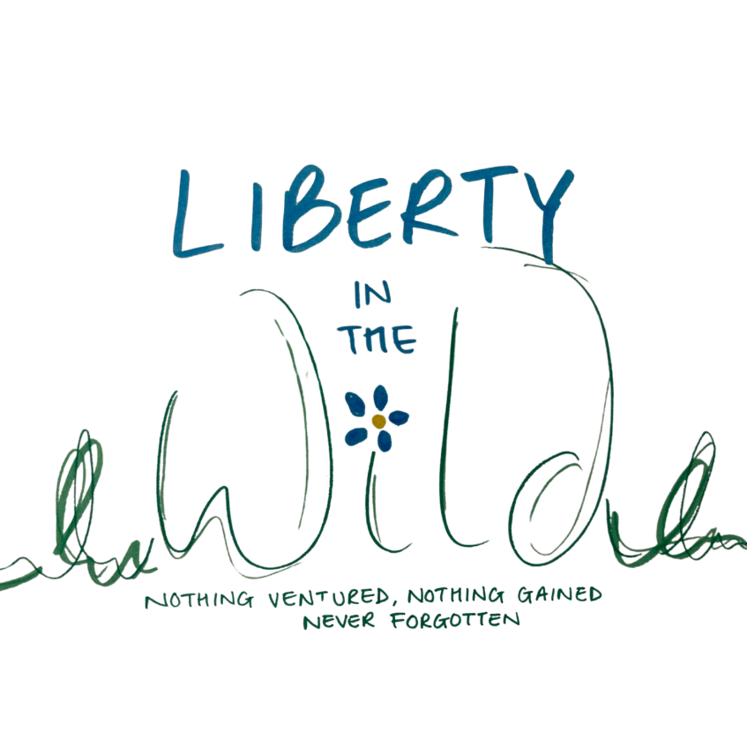

Approved by: | Kamilla Woodburn-Minott and Liz Crowford
Last reviewed on: | July 2024
Next review due by: | July 2025

Table of Contents

Why use the Internet and what are the benefits?

Pupils, Staff and Parents

Internet Access

Evaluating Internet Content

Publishing images

Managing social networking

Managing Filtering

Managing email

Video Conferencing

Managing Information Services

Protecting personal data

E-safety complaints

Community use of ICT and the Internet

Appendix 1 E-safety links and resources

Appendix 2 E-safety within the IT Scheme

The e-safety role is part of the job description of the Directors.

Our e-Safety Policy has been written by LITW, building on the SMBC Schools e-Safety Policy and Government guidance. It has been agreed by the senior management and approved by members of our advisory board.

The e-Safety Policy and its implementation will be reviewed every year or as the need arises and needs to be read in conjunction with the centre’s mobile phone policy.

The safety of children and staff is paramount at all times.

Why use the Internet and what are the benefits?

The purpose of Internet use at Liberty in the Wild is to raise educational standards, to promote pupil achievement, to support the professional work of staff and to enhance the management functions of the centre.

Internet use is part of our statutory curriculum and a necessary tool for learning.
Internet access is an entitlement for students who show a responsible and mature approach to its use.
The Internet is an essential element in 21st century life for education, business and social interaction. Liberty in the Wild has a duty to provide students with quality Internet access as part of their learning experience.
Pupils use the Internet widely outside of attending the centre and will need to learn how to evaluate Internet information and to take care of their own safety and security.

Benefits from Internet use
- access to world-wide educational resources including museums and art galleries and to experts in many fields for pupils and staff;
- inclusion in the National Education Network connecting all UK schools;
- educational and cultural exchanges between pupils world-wide;
- vocational, social and leisure use in libraries, clubs and at home;
- professional development for staff through access to national developments, educational materials and effective curriculum practice;
- collaboration across support services and professional associations;
- improved access to technical support including remote management of networks and automatic system updates;
- exchange of curriculum and administration data with SMBC and DCFS;
access to learning wherever and whenever convenient.

Liberty in the Wild will be responsible for ensuring that:-

The Liberty in the Wild Internet access will be designed expressly for pupil use and will include filtering appropriate to the age of pupils.

Pupils will be taught what Internet use is acceptable and what is not and will be given clear objectives for Internet use.

Support for the community will take the form of :-
Pupils

Rules for Internet access will be posted in all networked rooms.

Pupils will be informed that Internet use will be monitored.

An e-Safety training programme will be delivered to all pupils to raise the awareness and importance of safe and responsible use of the Internet and other electronic communications tools. This programme is likely to focus on PSHE and ICT areas of learning.
Instruction in responsible and safe use will precede Internet access and will be reinforced at regular intervals.
Staff
All staff will be given the centre’s e-Safety Policy and its importance explained.

Staff are aware that Internet traffic can be monitored and traced to the individual user. Discretion and professional conduct is essential.
Staff that manage filtering systems or monitor ICT use will be supervised by senior management and have clear procedures for reporting issues.

Staff development in safe and responsible Internet use and on the Liberty in the Wild e-Safety Policy will be provided as required.

Parents
Parents’ attention will be drawn to the centre’s e-Safety Policy in newsletters, the brochure and on the Website.
Internet issues will be handled sensitively to inform parents without alarm.
A partnership approach with parents will be encouraged. This may include parents’ evenings with demonstrations and suggestions for safe home Internet use.
Internet Access
Liberty in the Wild will maintain a current record of all staff and pupils who are granted Internet access.
All users must read, sign and abide by the ‘Acceptable ICT Use Policy’ before using any centre ICT resource.

Parents will be informed that pupils will be provided with supervised Internet access.

All pupils must agree to comply with the Responsible Internet Use statement before they are granted access.
Parents will be asked to sign and return a consent form for pupil access.

Pupils and staff will be aware that the use of computer systems without permission or for inappropriate purposes could constitute a criminal offence under the Computer Misuse Act 1990.
Methods to identify, assess and minimise risks will be reviewed regularly.
The Directors will ensure that the e-Safety Policy is implemented and compliance with the policy monitored.
Pupils evaluating Internet content
Liberty in the Wild will ensure that the copying and subsequent use of Internet derived materials by staff and pupils complies with copyright law.
If staff or pupils discover unsuitable sites, the URL (address), time, date and content must be reported to the centre Directors.
Pupils will be taught to be critically aware of the materials they read and shown how to validate information before accepting its accuracy.
Pupils will be taught to acknowledge the source of information used and to respect copyright when using Internet material in their own work.
The evaluation of on-line materials is a part of the work in relation to every curriculum area.
Publishing images of staff and pupils
Photographs on Liberty in the Wild’s website and Educational software that include pupils will be selected carefully and will not enable individual pupils to be clearly identified.
Pupils’ full names will not be used anywhere on the website, particularly in association with photographs.
Written permission from parents or carers will be obtained before photographs of pupils are published on the Liberty in the Wild website.
Pupils’ work can only be published with the permission of the pupils.
Images of staff should not be published without their consent.
Managing social networking
Social networking sites and newsgroups will be blocked unless a specific use in the centre is approved.

Pupils are advised never to give out personal details of any kind which may identify them or their location. Examples would include real name, address, mobile or landline phone numbers, school, IM address, email address, names of friends, specific interests and clubs etc.
Pupils are advised not to place personal photographs on any social network space. They should consider how public the information is and consider using private areas. Advice will be given regarding background detail in a photograph which could identify the student or his/her location e.g. house number, street name, school or shopping centre.
Teachers’ official blogs or wikis should be password protected and run from the Liberty in the Wild website. Teachers should not run social network spaces for students on a personal basis. Teachers should not communicate with pupils through private social networking sites, even on educational matters, but should use official sites sanctioned by the centre.
Pupils will be advised on security and encouraged to set passwords, deny access to unknown individuals and instructed on how to block unwanted communications. Students will be encouraged to invite known friends only and deny access to others. They will be advised not to publish specific and detailed private thoughts.
Liberty in the Wild is aware that bullying can take place through social networking, especially when a space has been setup without a password and others are invited to see the bully’s comments. Incidents of bullying through social networking will be dealt with in line with the centres policy on bullying.
Managing filtering
Liberty in the Wild will work in partnership with Local Authorities and Becta to ensure filtering systems are as effective as possible.
If staff or pupils discover unsuitable sites, the URL, time and date must be reported to a senior member of staff.

Senior staff will ensure that regular checks are made to ensure that the filtering methods selected are appropriate, effective and reasonable.

Any material that Liberty in the Wild believes is illegal must be reported to appropriate agencies such as IWF or CEOP (addresses later).

Managing emails
Pupils may only use approved email accounts on the centre’s system.
Pupils must immediately tell a teacher if they receive offensive email.
Pupils must not reveal personal details of themselves or others in email communication, or arrange to meet anyone without specific permission.
Use of words included in the filtering/checking ‘banned’ list will be detected and logged.
Whole-class or group email addresses will be used where possible and email should be supervised in a manner appropriate to the age of pupils concerned.
Access in centre to external personal email accounts may be blocked.

Email sent to external organisations should be written carefully and authorised before sending, in the same way as a letter written on provision centre headed paper.
The forwarding of chain letters is not permitted.
Email addresses should be published carefully, to avoid spam harvesting.

Video Conferencing (including Internet telephony such as Skype)

The equipment and network
All video conferencing equipment in the work areas must be switched off when not in use and not set to auto answer.
IP video conferencing should use the educational broadband network to ensure quality of service and security rather than the Internet.
Equipment connected to the educational broadband network should use the national E.164 numbering system and display their H.323 ID name.
External IP addresses should not be made available to other sites.
Video conferencing contact information should not be put on the centre website
The equipment must be secure and if necessary locked away when not in use.
Users
Pupils should ask permission from the supervising teacher before making or answering a videoconference call.
Video conferencing will be supervised at all times
Parents and guardians must agree for their children to take part in videoconferences.
Unique log on and password details for the educational video conferencing services will only be issued to members of staff and kept secure.
Content
When recording a lesson, written permission should be given by all sites and participants. The reason for the recording must be given and the recording of videoconference should be clear to all parties at the start of the conference.
Recorded material will be stored securely
If third-party materials are to be included, check that recording is acceptable to avoid infringing the owners’ Intellectual Property Rights (IPR).
Video conferencing is a challenging activity with a wide range of learning benefits. Preparation and evaluation are essential to the whole activity.
Establish dialogue with other conference participants before taking part in a videoconference. If it is a off centre site, it is important to check that they are delivering material that is appropriate for your class.

Emerging technologies will be examined for educational benefit and a risk assessment will be carried out before use in is allowed.
Mobile phones will not be used during sessions. The sending of abusive or inappropriate text messages is forbidden.

Managing Information Services
The security of the centre information systems will be reviewed regularly.
Virus protection will be updated regularly.
Security strategies will follow Solihull MBC guidelines.
Personal data sent over the Internet will be encrypted or otherwise secured.
Portable media may not be used without specific permission followed by a virus check. Where they are used to store personal information they will be encrypted
Unapproved system utilities and executable files will not be allowed in pupils’ work areas or attached to email.
Files held on the centre’s network will be regularly checked.
The ICT co-ordinator / network manager will review system capacity regularly.

Protecting personal data

Personal data will be recorded, processed, transferred and made available in compliance with to the Data Protection Act 1998.

e-safety complaints
Formal complaints of Internet misuse will be dealt with by a senior member of staff.
Any complaint regarding misuse must be referred to the Directors who will follow use the agreed Warwickshire Council procedures.
Pupils and parents will be informed of the complaints procedure.
Parents and pupils will need to work in partnership with staff to resolve issues.
Sanctions for young people within the provision discipline policy include:
interview/counselling by Senior member of staff.
informing parents or carers;
removal of Internet or computer access for a period.

Community use of ICT and the Internet

Liberty in the Wild will liaise with local organisations to establish a common approach to e-safety.
Liberty in the Wild will be sensitive to Internet related issues experienced by the young people off the premises, e.g. social networking sites, and offer appropriate advice.

July 2024

E-safety links and resources
Links

West Midlands Regional Broadband E-Safety Information
Hectors World KS1 Resource
E-safety quiz for parents
E-safety games for Primary and Secondary
Digizen Cyber bullying
Know IT All for Primary Schools
E-Safety by Ormesby Primary School
London Grid for Learning E-safety activities
Vodafone E-safety guide for parents
Kent E-safety resources
Think You Know
CBBC Stay Safe
Child Net International
PHONE Brain
Becta e-safety
Know It All SEN resources
Cyber Bullying Keep Control
Kids Performance Plymkids
Teach Today - Living with technology

- ‘Zip it, Block it, Flag it’ a government campaign how to stay safe online.
http://direct.gov.uk/clickcleverclicksafe

