Whistle-Blowing policy
Liberty in the Wild

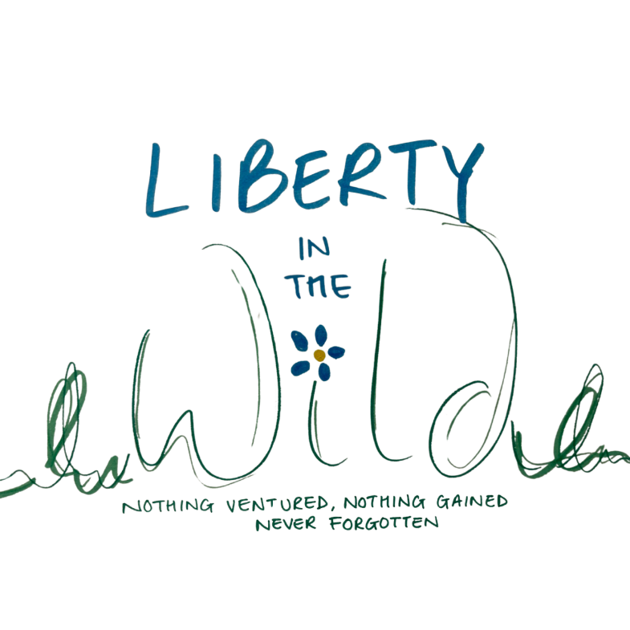

Approved by: | Kamilla Woodburn-Minott and Liz Crowford
Last reviewed on: | July 2024
Next review due by: | July 2026

Table of Contents
- One-Page Overview 4
- Policy 5
- Policy Aims 5
- Scope of Policy 6
- Protection for workers 7
- Roles and Responsibilities 8
- Raising a Concern 9
- Procedure 10
- Confidentiality 11
- Anonymous Allegations 11
- Malicious Allegations 11
- Register of Concerns 12
- Monitoring Arrangements 12
- Making Disclosures outside the Council 12
Appendix 1: Standard Form for Whistleblowing Allegations 15

One-Page Overview

Whistleblowing is for:
  - All employees (including teaching and non-teaching staff), people working on behalf of Liberty in the Wild Ltd (including sub-contractors), advisory board members and service users.
  - Genuine concerns about malpractice or impropriety that you believe to be in the public interest, including but not limited to mismanagement, bribery, fraud and health and safety failures.

Whistleblowing is not for:
  - Raising employment concerns;
  - Making complaints relating to bullying or harassment issues;
  - Questioning financial or business decisions taken by Liberty in the Wild Ltd; or
  - Raising issues that have already been addressed under disciplinary, resolution or other procedures. You can, however, raise concerns about failure to properly follow these procedures.

Who can I contact to blow the whistle?
  - Your manager;
  - A Director, or
  - The Chair of the advisory board (Contact details on Page 9)
A standard whistleblowing form is available at Appendix 1.

Can I keep my name / identity secret?
You are encouraged to give your name when raising a concern. You can make an anonymous disclosure, but these are much less credible. All concerns will be treated in confidence and every effort made not to reveal the whistleblower’s identity.

What will happen to me if I blow the whistle?
Liberty in the Wild has a duty to protect whistleblowers and to make sure that you can raise concerns without fear of recrimination, reprisal, or be disadvantaged in any way.

I’m not sure I feel able to blow the whistle – how can I get help or advice?

- Contact the charity Protect (previously called ‘Public Concern at Work’) for free confidential advice about the best way to raise a concern. Their website address is www.protect-advice.org.uk or you can email them at whistle@protect-advice.org.uk or contact them on 020 3117 2520.
      - Speak with your Trade Union representative.

Policy
Liberty in the Wild is committed to the highest standards of honesty, openness, probity and accountability. In line with this commitment and as part of its governance arrangements, Liberty in the Wild encourages anyone who has a genuine concern about malpractice or wrongdoing within the Council to come forward without fear of reprisal and voice those concerns.

‘Whistleblowing’ is the term ordinarily used to describe the disclosure of information by an employee about malpractice that is occurring within the organisation. This will include any illegal, immoral, irregular, dangerous or unethical activity under their employer’s control. This can cover a broad range of matters, including mismanagement, bribery, fraud and health and safety failures.

Whilst the policy primarily covers employees (including teaching and non-teaching staff) and people working for or on behalf of the Council (including sub-contractors), Liberty in the Wild encourages volunteers (including Centre advisory board members) and service users who have a concern to raise it in the knowledge that it will be taken seriously and dealt with appropriately.

It is essential that disclosures of impropriety, irregularity or wrongdoing are dealt with appropriately and promptly. This complements the Anti-Fraud and Corruption policy which states that Liberty in the Wild will ‘Encourage and enable employees, parents, elected members, employees, partners, contractors and suppliers to raise serious concerns.’

This policy is intended to encourage and assist those individuals above, who believe they have discovered malpractice or impropriety, to raise their concerns within Liberty in the Wild in the first instance rather than overlooking a problem or raising concerns outside of the organisation.

This policy is not designed to question financial or business decisions taken by Liberty in the Wild nor should it be used to reconsider any matters, which have already been addressed under the disciplinary, resolution or other procedures. It can, however, be used to raise concerns about failure to properly follow procedures related to the above.

This policy has been developed in consultation with our recognised Trade Unions including Teacher Associations and complies with the best practice in the British Standards publication ‘Whistleblowing Arrangements Code of Practice’ issued 2008.

Policy Aims
This policy aims to:
  - Provide an opportunity for employees and other individuals to raise genuine concerns internally.
  - Encourage all employees and other individuals to feel confident in raising serious concerns and to question and report concerns about malpractice.

  - Ensure children, young people and vulnerable adults feel able to raise concerns as service users.
  - Provide a mechanism for individuals to obtain advice or to raise concerns confidentially and in a method to suit them.
  - Reassure those reporting concerns that they will be protected from reprisals or victimisation for confidential reporting.
  - Ensure there are relevant support measures in place for individuals using the reporting procedures.
  - Ensure that concerns raised are given proper consideration and, where possible, provide a response.
  - Make individuals aware of how they can pursue their concerns if they are not satisfied with Liberty in the Wild’s proposed course of action.

Scope of Policy
There are existing procedures in place that enable employees to raise a concern relating to their employment. These would normally be made under the Resolution procedure. Employees should consult this policy and obtain advice from Human Resources (HR) in relation to discrimination, harassment, bullying and victimisation.

This policy also complements the detailed guidance issued by professionals in relation to abuse of children, young adults and vulnerable adults.

This policy is intended to cover ‘qualifying disclosures’ that fall outside the scope of the procedures detailed above. A qualifying disclosure is one made in the public interest by a worker who has a reasonable belief that any of the following is being, has been or is likely to be committed:
  - A criminal offence.
  - An illegal or dishonest practice.
  - Disclosures relating to miscarriages of justice.
  - Unauthorised uses of public funds.
  - Possible fraud, corruption or malpractice.
  - Breaches of Liberty in the Wild policies or procedures.
  - Breaches of agreed Liberty in the Wild or governing body procedures.
  - Unsafe or unhealthy working practices that put the safety of employees and/or visitors at risk.
  - Failure to comply with legal obligations.
  - Risks to the environment.
  - Other unethical conduct by officers, elected members, or other parties associated with Liberty in the Wild, e.g. contractors, partners, volunteers etc.
  - The deliberate concealing of information relating to any of the above matters.
  - Allegations of abuse to children, young people and vulnerable adults.
  - Failure to report/investigate abuse.

These procedures are in addition to Liberty in the Wild’s own complaints procedures and other statutory reporting procedures that apply to some areas of Liberty in the Wild’s work and responsibilities. This policy should not be used to raise individual employment terms and conditions issues that fall outside the above list.

Liberty in the Wild has procedures in place by which complaints or concerns relating to employment can be raised through the Resolution procedure. Equally, there is also disciplinary policy in place. Employees should be aware that if they decide to raise a concern related to their own employment at an Employment Tribunal, that any decision made by a Tribunal will examine whether the matter has been raised with the employer in the first instance when determining any award.

Advice on the appropriateness of these other procedures rather than the Whistleblowing procedure can be obtained from the tors.

Email - whistlelowing@libertyinthewild.co.uk

Advice on the complaints procedure can be found at www.libertyinthewild.co.uk

Protection for workers

The Public Interest Disclosure Act 1998 amends the Employment Rights Act 1996 to introduce new rights for workers not to be subjected to dismissal or detriment by their employer for making a protected disclosure.

A qualifying disclosure will be ‘protected’ if the worker reasonably believes that it is made “in the public interest”. A worker has the right not to be subjected to any detriment by his or her employer on the grounds that he or she has made a protected disclosure. ‘Detrimental treatment’ includes being unfairly penalised, disciplined or subjected to any other detriment (including termination of the
employee’s contract where he or she is an employee). In addition, whistleblowers are protected from suffering a detriment, bullying or harassment from another worker.

It is an integral part of this policy that employees can ‘blow the whistle’ without fear of recrimination, reprisal, or be disadvantaged in any way.

Liberty in the Wild recognises that the decision to report a concern can be a difficult one to make, not least because of fear of reprisal from those responsible for the alleged malpractice. SMBC will not tolerate harassment or victimisation in any form and will take action and put in place support measures to protect employees who raise a concern.

Any investigation into allegations of potential malpractice will not influence or be influenced by any disciplinary or redundancy procedures that already affect employees. Any employee who makes an allegation that turns out to be unfounded will not be penalised if there is evidence that they had a genuine concern, or belief, when making the allegation.

It is a disciplinary offence to victimise an employee for raising a protected disclosure. It is also a disciplinary offence to maliciously make a false allegation.

Roles and Responsibilities
Liberty in the Wild recognises that the decision to report a concern can be difficult and uncomfortable. Liberty in the Wild is therefore committed to supporting individuals through the process and protecting them from any adverse repercussions.

Audit Committee has overall responsibility for monitoring SMBC’s whistleblowing procedures.

Managers (including those with responsibility for safeguarding children or vulnerable adults) and Directors are required to ensure all workers are aware of this policy, to take all issues raised seriously and to report any concern to Internal Audit within 2 working days of the matter being brought to their attention.

Employees, centre staff (teaching and non-teaching) and other workers, who genuinely believe that people they observe are behaving in a way that seems inappropriate or have a serious concern about the legitimacy of an aspect of a service, will be acting in the public interest by reporting the concern. They should, however, have reasonable grounds for raising the concern, in the public interest.

Human Resources can advise on the application of this policy and the support arrangements for employees. HR Managers and Advisors will be able to provide this advice.

Internal Audit has overall responsibility for advising on the application of this policy, maintaining a register, monitoring all whistleblowing concerns and reporting details to relevant stakeholders.
Trade Unions and Teacher Associations are a point of contact and can provide advice and guidance to individuals raising concerns.

Raising a Concern

Employees, centre staff, members, partners or contractors

This policy seeks to encourage and assist individuals to disclose information through an appropriate channel. Ideally employees should raise concerns with their manager in the first instance, however, where they feel that this is not appropriate or would prefer to speak to someone independent, they can contact the Directors or Chair of the advisory board. See www.libertyinthewild.co.uk for contact details.

Where applicable, the individual may want to raise the matter with a Trade Union representative.

A diagram of how to report a concern is included at Appendix 1. Service Users (Adults and Children)
In accordance with Liberty in the Wild’s commitment and responsibility to safeguard vulnerable individuals, it is the responsibility of all employees to be vigilant and to raise any concerns to their manager (unless it is their manager about whom they have the concerns). Where employees have a concern that a colleague, other SMBC employee or volunteer is behaving inappropriately in relation to children, young people or vulnerable adults, they should follow the corporate Managing Allegations procedures.

In addition, Liberty in the Wild’s safeguarding procedures should be followed when there are concerns about a child, young person or vulnerable adult. Details of Liberty in the Wild’s safeguarding guidance can be found at www.libertyinthewild.co.uk.
If an employee has a concern about an individual from another agency who works with children and young people, this should also be discussed with a line manager and managed in accordance with the safeguarding procedures.

Procedure
Initial contact

Concerns may be raised both verbally and in writing. Employees and other workers who wish to report a concern should give as much detail as possible, e.g. background and history of the concern, giving names, dates and places, where possible, and the reasons for making a disclosure.

A standard form is available at Appendix 2 to assist with this. It can also be completed on line by sending an email to: whistleblowing@libertyinthewild.co.uk

The individual reporting the concern must be able to demonstrate that there is an honest and reasonable suspicion that malpractice or impropriety has occurred, is occurring or is likely to occur and the disclosure is in the public interest.

Whilst Liberty in the Wild would like details of the individual making the complaint, it is recognised that this may not always be possible. Concerns can be raised confidentially, which means that we will not reveal your name unless required by law to do so.

The investigation

The Chair of the advisory board and Directors will liaise with relevant professionals to ensure that all allegations are dealt with correctly.

Where appropriate, the individual raising the concern will be contacted and a meeting arranged. For employees this can be away from their normal place of work if this is preferred. This will enable the investigating officer to discuss the concern further and ask additional questions.

Initial enquiries will be made to decide whether an investigation is appropriate. It may be possible to resolve some concerns without the need for an investigation. The individual will be notified about how Liberty in the Wild proposes to deal with the concern within 10 working days.

The following matters may need to be considered as part of the investigation:

  - The most appropriate method of investigation and the skills needed.

  - The evidence that is needed to substantiate the concern.

  - Whether the matter needs to be referred to the Police, or other external third parties.
  - What involvement External Auditors should have.

  - Whether an independent inquiry is appropriate.

The investigating officer will report her/his findings to the Chair of the advisory board. Depending on the significance of the concern and the findings, it may be necessary for other parties to be informed.

The individual raising the concern will, as far as is possible and with due regards to third party rights, be notified of the outcome, subject to legal constraints.

If an individual is not satisfied that her/his concern is being properly dealt with, they have the right to raise the matter in confidence with the Monitoring Officer (who will inform the Chair of the advisory board).

Confidentiality
All concerns will be treated in confidence and every effort made not to reveal the individual’s identity. However, whilst making all reasonable effort to maintain the confidentiality of the matter as a whole, at a certain stage in the investigation it may be necessary to make the origin of the complaint known to the person or persons the allegations relate to. This will be discussed with the individual at the time and, where possible, agreed.

Individuals should, however, be aware that their identity may be revealed by inference. Should this be necessary, individuals will be contacted and made aware of this before any details are revealed.

Anonymous Allegations
This policy encourages individuals to put their names forward with any disclosures they make. Concerns expressed anonymously are much less credible but will be considered at Liberty in the Wild’s discretion. In exercising this discretion, the factors to be taken into account will include:

  - the seriousness of the issues raised;

  - the credibility of the concern and the evidence available; and

  - the likelihood of confirming the allegation from attributable sources.

Malicious Allegations
If employees make an allegation in the public interest and without personal gain, which is based on evidence or observation, but it is not confirmed by a subsequent
investigation, no action will be taken against that employee and they will be fully supported after the event.

In making a disclosure an individual should exercise due care to ensure accuracy of the information. However, if an individual makes an allegation that knowingly is untrue, or they have acted maliciously, unethically or for personal gain, disciplinary action may be taken, which could result in dismissal. For non-employees other action may be considered.

Equally, if malicious allegations are made against the employee, Liberty in the Wild will ensure that the employee is fully supported and that appropriate disciplinary action is taken against the person making the malicious allegations.

If a child or service user makes an allegation, which could be malicious, appropriate action will be taken under the Managing Allegations against Employees Policy.

Register of Concerns
The Directors will maintain a register of all concerns that have been raised under this policy within Liberty in the Wild. All Liberty in the Wild managers will notify the Directors within 2 days of a concern being raised so that it can be included in this corporate register. This will include the following information:
  - the date the concern was raised;
  - a summary of the concern including the individuals involved;
  - the date the investigation commenced;
  - the Investigating Officer appointed and details of other individuals involved;
  - the outcome(s) of the investigation and a summary of actions taken; and
  - the date the individual raising the concern was notified of the outcome.
All officers receiving an allegation under this policy must ensure that the Chair of the advisory board receives prompt information in relation to allegations to enable this register to be maintained correctly. This information will be held in accordance with the Data Protection Act.

Monitoring Arrangements
The Chair of the advisory board will provide a confidential summary report to the Directors every three months.

Making Disclosures outside the Council
This policy provides individuals with a mechanism to report an act of perceived wrongdoing that will enable Liberty in the Wild to take corrective action. If the investigation finds the concerns unsubstantiated and all internal procedures have been exhausted, but an individual is not satisfied with the outcome, Liberty in the Wild recognises the lawful rights of individuals to make disclosures outside Liberty in the Wild. Disclosures can be made to
organisations such as the Health and Safety Executive, Audit Commission, professional bodies and the Police.

This policy has been developed to enable employees to express concerns on the basis that it is in the public interest to make such matters known to Liberty in the Wild. However, reporting of a concern does not mean that such matters should be made available for public consumption through the press and/or social media.

Disclosure to the press is prohibited during the course of, or after completion of, an investigation either conducted internally or via those external bodies known as ‘prescribed persons’ or regulatory bodies. Disclosure to the press in these circumstances may lead to disciplinary action against the employee.

If matters are taken outside Liberty in the Wild, individuals should ensure that this does not result in disclosing confidential information. It may, therefore, be necessary for advice to be sought from the Directors at directors@libertyinthewild.co.uk.

Appendix 1: Standard Form for Whistleblowing Allegations
Liberty in the Wild is committed to the highest possible standards of openness, probity and accountability. In line with that commitment, we expect employees and others that we deal with who have concerns about any aspect of Liberty in the Wild’s work to come forward and voice those concerns. It is recognised that most cases will have to proceed on a confidential basis. If you wish to make a report please use this pro-forma.

Background and history of the concern (giving as much detail as possible):

- The reasons why you are particularly concerned about the situation.

- Please set out how you would like to see the issue dealt with?

(Please attach additional sheets if necessary)

You are encouraged to put your name to this report, as concerns expressed anonymously are much less powerful. Liberty in the Wild will consider all reports as far as is possible, but we encourage you to give your name and details below, if you feel able.

I confirm that I believe the above to be a qualifying disclosure and this information is disclosed in the public interest.

Name: Directorate/Job Title:
Contact Details (Tel / Email): Signature:
Date:

PLEASE SEND THIS FORM TO:

whisleblowing@libertyinthewild.co.uk

Page 15 of 15

